Azure & Cloud Computing
1: Desktop Computing
2: Client Server Computing
3: Cluster Computing
4: Grid Computing
4: Cloud Computing

Cloud Computing
Q: What is Cloud Computing?
Ans: NIST: Business Innovation
Amazon
World wide Data Center Open
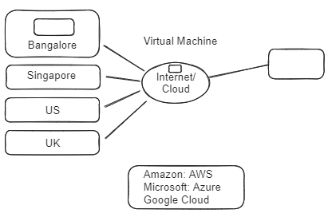

High Availability Through Azure's Availability Zone:
Region Architecture:
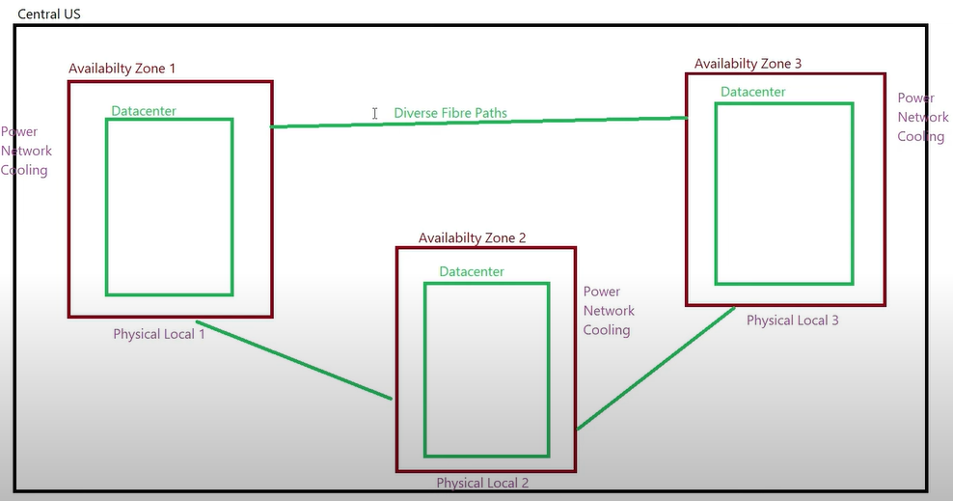

Problem 1: Deploy in only one server and server got down so all services also got down
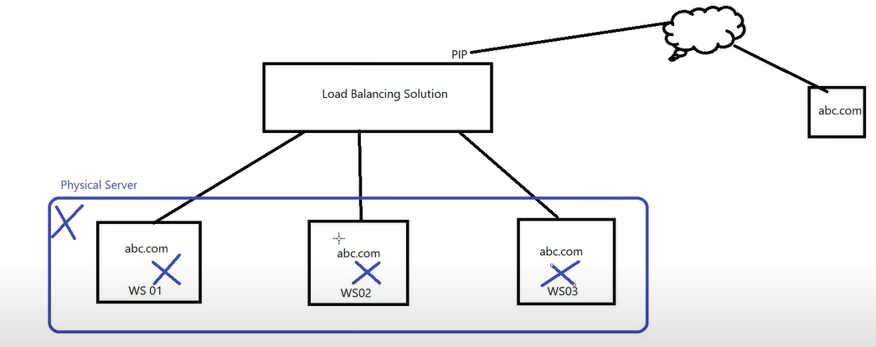

Problem 2: Deploy in only one data Center and all services deploy inside the data center and that data center got down by any reason like cooling or networking, Power and so the services also got down.
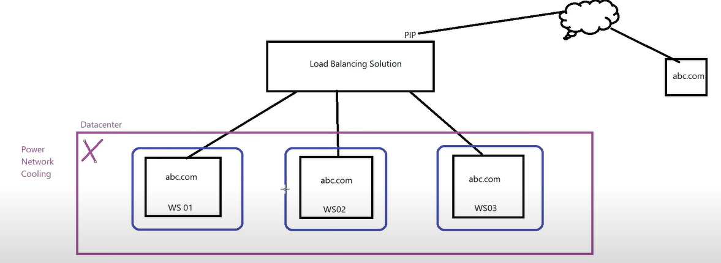
Solution 1: deploy datacenter in different locations.
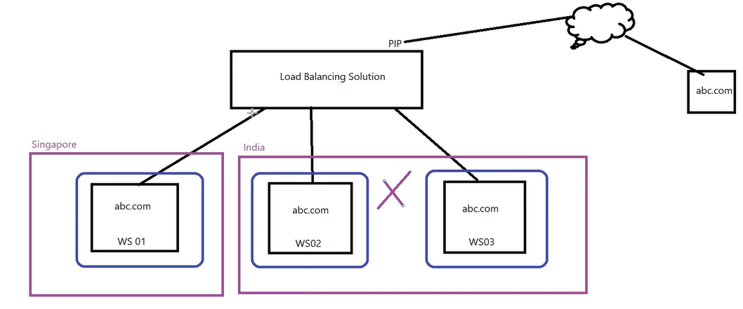

Solution 2: By using Azure's Availability Zone, where IP is Internet protocol (Load balancer).
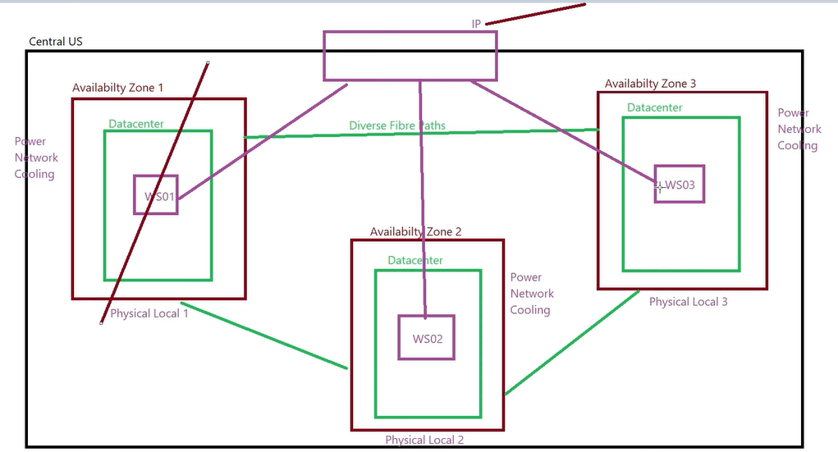

Now Check how to create a Virtual Machine:
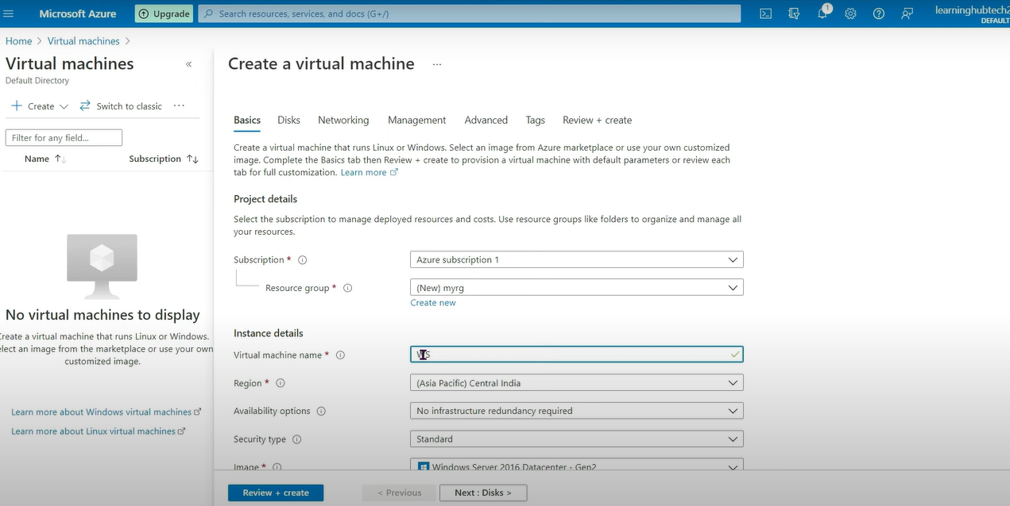
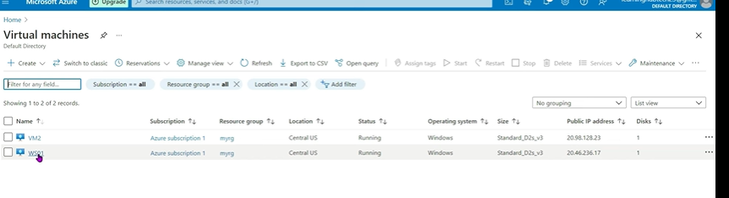

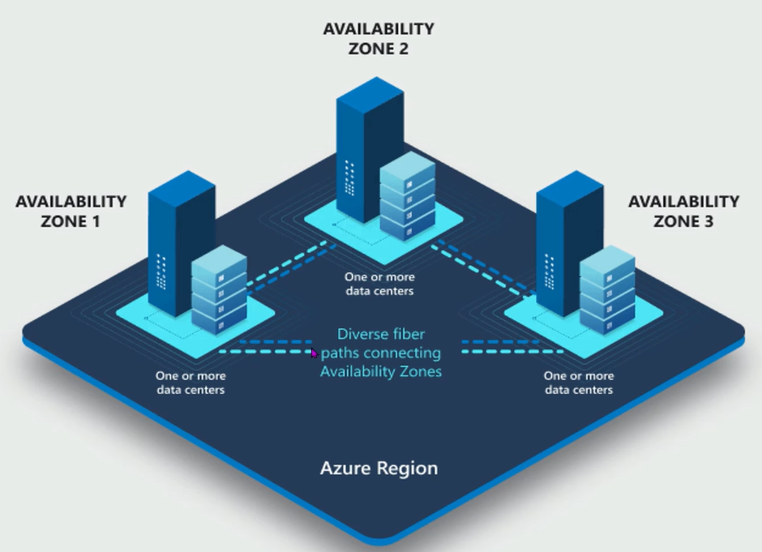

Availability Zone only configure some few locations only.
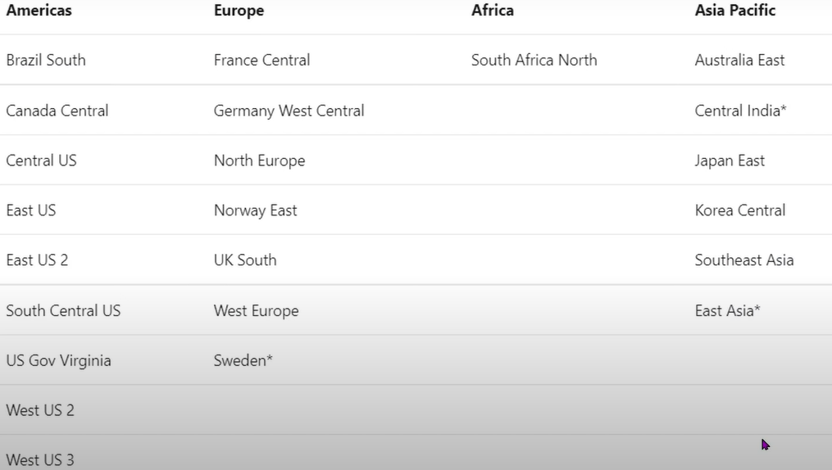
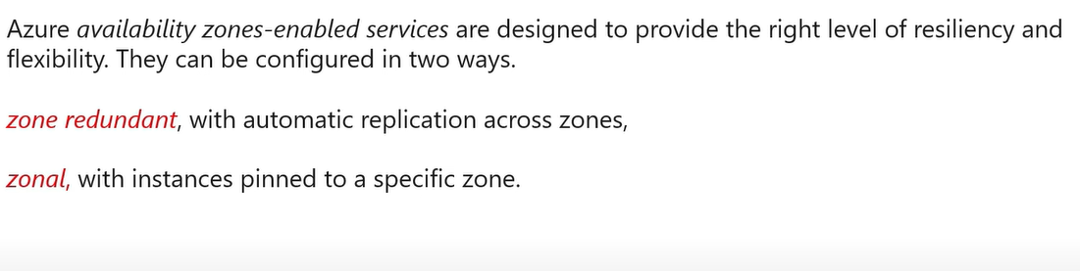
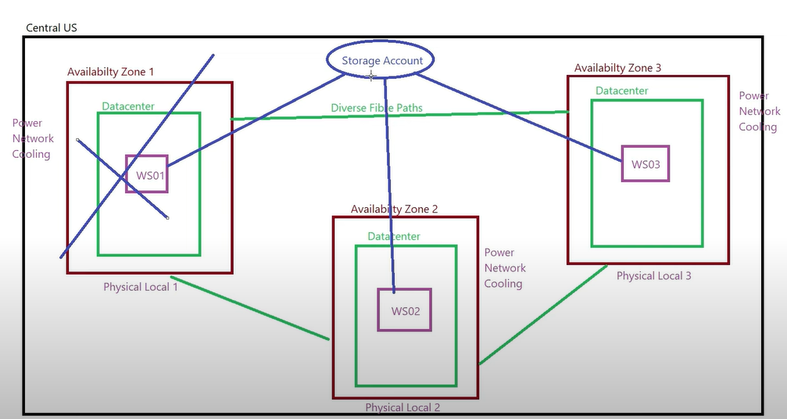
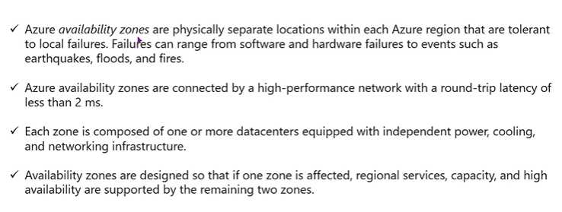

Azure Architecture:
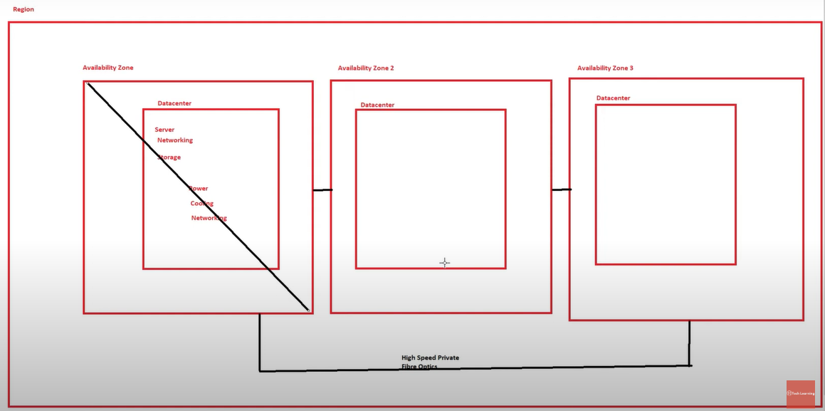
If Region is failed, then what?
Then Azure will provide the solution of this
Region Pair: Distance between 2 region is 300 miles away.
Geography>>Region>>Availability Zone >> Data Centers
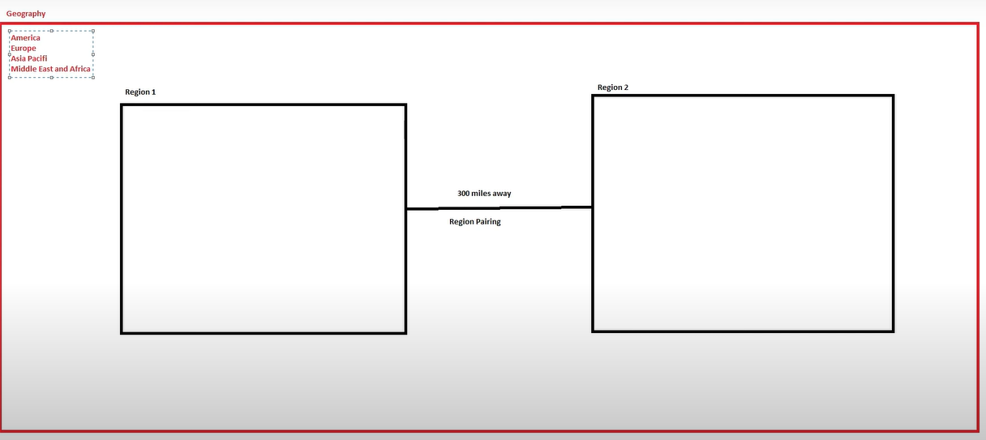
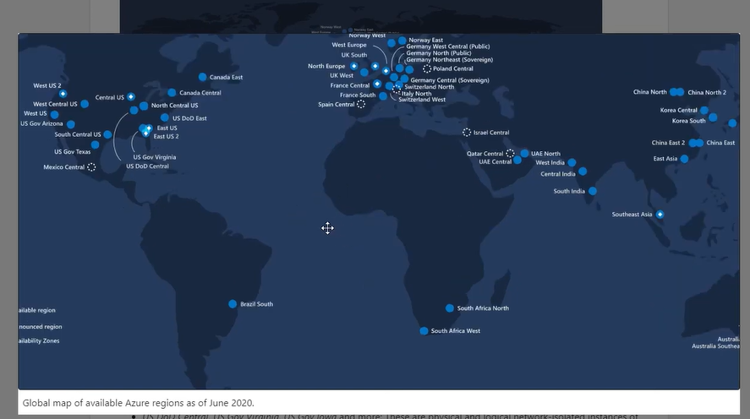
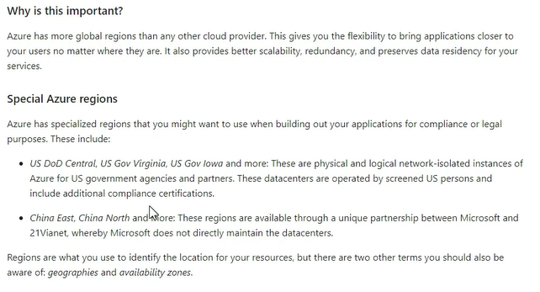
Availability Zone option available in site
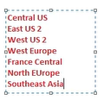
Azure Virtual Machine (VM):
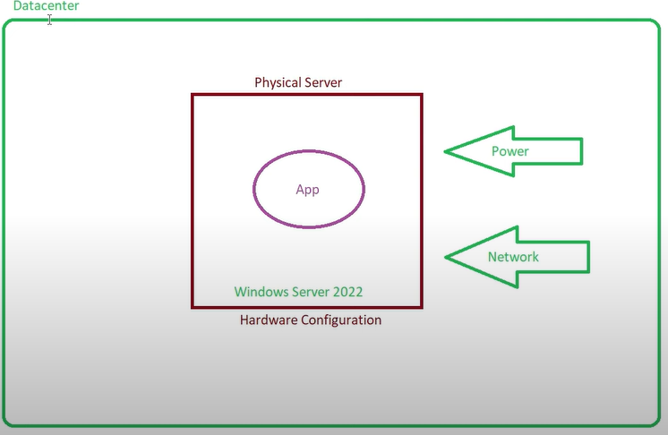
This is the traditional Technique but in this we have lots of drawbacks.
1: Buy Server
2; Buy Operating system
3: Configuration costing because we have bought the full ownership pack of server
Solution: Azure
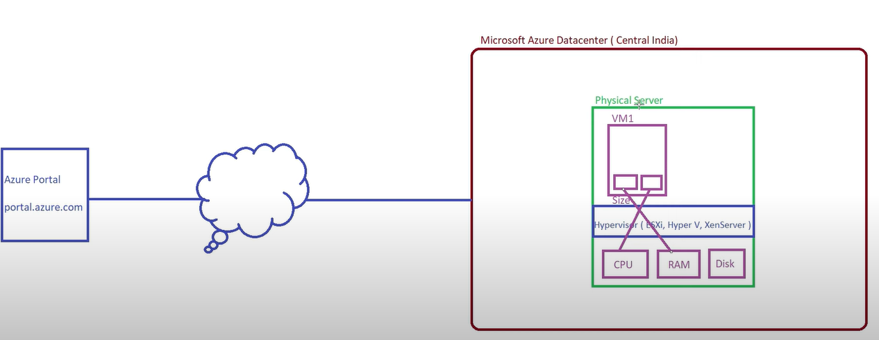
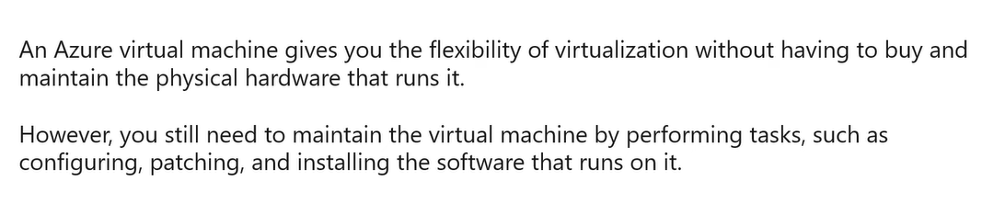

Create Windows Based Azure VM:

